Lecture 6: Elliptic Curves Cryptosystem
Abstract
In 1985, Neil Koblitz and Victor Miller (compared to RSA 1978) independently proposed the Elliptic Curve Cryptosystem(ECC), whose security rests on the discrete logarithm problem over the points on an elliptic curve. ECC can be utilized to provide both a digital signature scheme and an encryption scheme. The company is based in Canada, called Certicom.
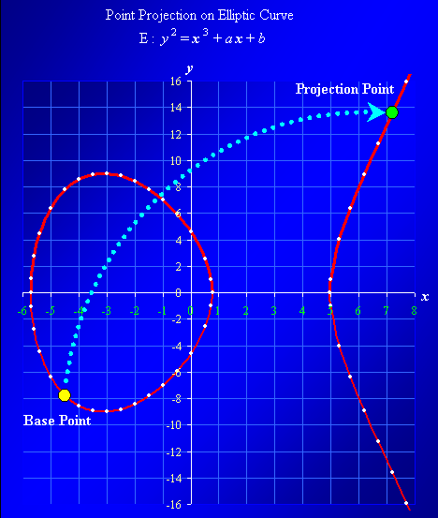

An elliptic curve, defined modulo a prime p, is the set of solutions (x, y) to an equation of the form:
y² = x³ + ax + b (mod p)
for two parameters a and b.

If (x, y) satisfies the above equation then (x, y) is a point on the elliptic curve. In fact, another popular elliptic curve can also be defined over the finite field consisting of 2^{m} elements. Such a representation offers extra efficiency in the operation of the ECC. Using some particularly deep mathematics, it is possible to define the “addition” of two points on the elliptic curve.

Suppose (x₁, y₁) and (x₂, y₂) on an elliptic curve

y² = x³ + ax + b
then
(x₃, y₃) = (x₁, y₁) ⊕ (x₂, y₂)
P₃(x₃, y₃) = P₁(x₁, y₁) ⊕ P₂(x₂, y₂)

will always be another point on the curve. The elliptic curve discrete logarithm problem can be stated as follows.

Fix a prime p and an elliptic curve. λ⊗(x₀, y₀) represents the base point (x₀, y₀) added to itself λ times. Suppose (x_{λ}, y_{λ}) is a multiple λ of (x₀, y₀), so that

(x_{λ}, y_{λ}) = λ⊗ (x₀, y₀)

for some positive integer λ.
From base point, (x₀, y₀) shall be projected to (x_{λ}, y_{λ}) via multiplication key λ. Given the 2 points it is an intractable to compute the key λ.

Then the elliptic curve discrete logarithm problem is to determine λ given (x₀, y₀) and (x_{λ}, y_{λ}). The security of the ECC rests on the difficulty of the elliptic curve discrete logarithm problem. As was the case with the integer factorization problem and the discrete logarithm problem modulo p, no efficient algorithm is known to solve the elliptic curve discrete logarithm problem. In fact, another advantage of the ECC is that the elliptic curve discrete logarithm problem is believed to be harder than both the integer factorization problem and the discrete logarithm problem modulo p. This extra difficulty makes the ECC the strongest public-key cryptographic system known today. Moderate security can be achieved with the ECC 160-bits using an elliptic curve defined modulo a prime p that is several times shorter than 1024-bits. Today popular ECC carry 256-bit size compared to standard RSA 2048-bit

Efficiency
Just as modular exponentiation determined the efficiency of integer factorization and discrete logarithm systems, so it is the calculation of

(x_{λ}, y_{λ}) = λ⊗ (x₀, y₀)
for a point (x₀, y₀) on the elliptic curve and some integer λ which dominates the calculations involved in the operation of the ECC. The process of adding elliptic curve points requires a few modular calculations, so in all arithmetic operations of a public-key
cryptographic system is dependent upon efficient modular arithmetic.

Thus, in the case of the ECC, security rests on the elliptic curve discrete logarithm problem, while efficiency is dependent on the fast calculation λ ⊗ (x₀, y₀) for some number λ and a point (x₀, y₀) on the curve.

Security
In general, the elliptic curve discrete logarithm problem is currently believed to be harder than integer factorization problem. Key size recommendations are presented for several classical cryptosystems based on the hypotheses:

- Relative to the breaking of a 56-bit DES key would cost 5*105 Mips Years (or equivalent to using USD 50 millions machine within 2 days) in 1982
- Moore’s Law projects that computing power per chip doubles every 18 months
- The amount of computing power and RAM would double every 18 months per USD 1
- Monetary budget available to the ones breaking cryptographic keys doubles every ten years due to the trend of US GNP doubling on average every ten years
- On average it takes 18 months for cryptanalytic developments affecting classical asymmetric system to become twice as effective without any major breakthrough.

The graph below depicts the summary of the key length to be considered sufficiently secure for RSA versus ECC according to conservative estimate having some theoretical progress in solving ECDLP.
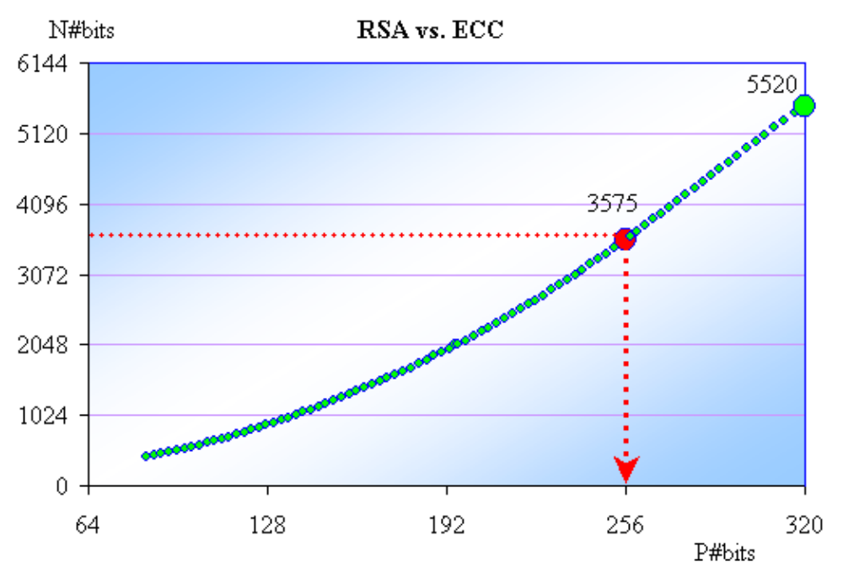

The security provided by any public key cryptographic system depends on several factors. Some important considerations are the mathematical soundness of the algorithm, the management of keys, and the implementation of the system in an application. The safety of the ECC is dependent on the work needed to find or compute the discrete logarithm of a very large number. Mathematicians and computer scientists have been working to find a simple solution to the problem of finding logarithms for a long time. To date, only incremental improvements in computation have been attained through the use of more powerful computers.

Elliptic Curves
The most popular elliptic curve is of the form

y² = x³ + ax + b

The figure below gives a series of curves for various values of a and a fixed b = 7.

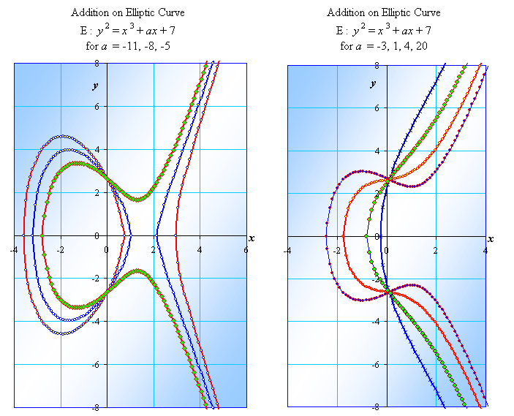

Elliptic Curves over Finite Fields
Let us go through a quick introduction to the theory of elliptic curves. Let p > 3 be an odd prime. An elliptic curve E over the field F_{p} is defined by an equation of
the form
y² = x³ + ax + b

where a ∈ F_{p}, b ∈ F_{p}, and 4a³ + 27b² ≠ 0 (mod p).

The set E(F_{p}) consists of all points (x, y) which satisfy the elliptic curve equation above together with a special point (∞_{x}, ∞_{y}) called the point at infinity.

example
Let p = 23 and consider the elliptic curve E: y² = x³ + x + 4 defined over F₂₃.
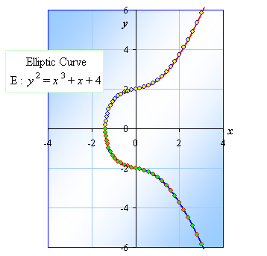

Note that
4a³ + 27b² = 4 + 27 ⋅ 16
= 436 ≡ 22 ≠ 0 (mod 23).
so E is indeed an elliptic curve. The points in the E(F₂₃) are
(0, 2) | (0, 21) | (1, 11) | (1, 12) | (4, 7) | (4, 17)
(7, 3) | (7, 20) | (8, 8) | (8, 15) | (9, 11) | (9, 12)
(10, 5) | (10, 18) | (11, 9) | (11, 14) | (13, 11) | (13, 12)
(14, 5) | (14, 18) | (15, 6) | (15, 17) | (17, 9) | (17, 14)
(18, 9) | (18, 14) | (22, 5) | (22, 19) | (∞_{x}, ∞_{y}).
There are 29 points in E(F₂₃). The point at infinity (∞_{x}, ∞_{y}) shall serve as the identity of E(F₂₃).
Compare to the normal power mod p values the points on the Elliptic curve gives much richer content. The figure below show the graph of 5^{x} mod 23. They are cyclic about the order of p – 1 = 22.

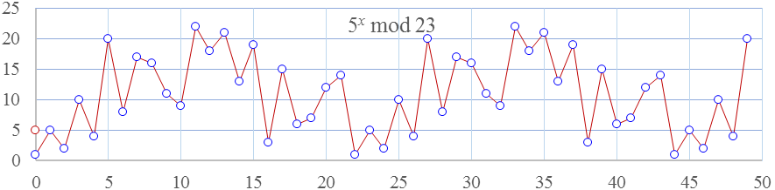

There are however 29 point on the Elliptic over the finite field F₂₃ including the identity
I = (∞_{x}, ∞_{y}) as a point at infinity.
The figure below show the distribution of the points in the finite field F₂₃.
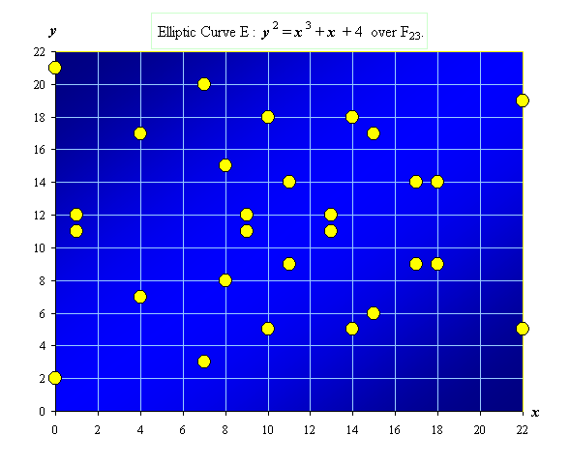

Arithmetic Operations

Let an elliptic curve be E: y² = x³ – 4 x + 1 as shown in the figure below.
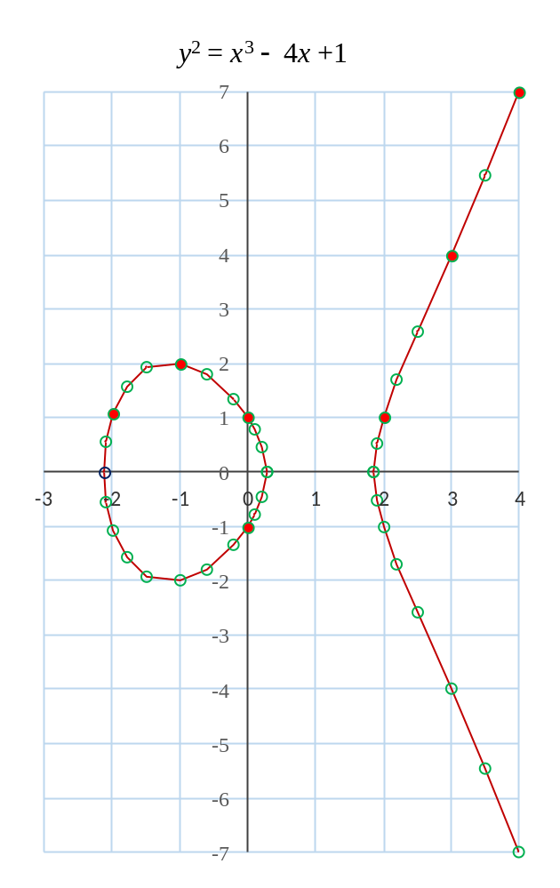

The addition operation is illustrated geometrically.

Let (x₁, y₁) = (–2, 1) and (x₂, y₂) = (–1, 2)
(x₃, y₃) = (x₁, y₁) ⊕ (x₂, y₂)
= (–2, 1) ⊕ (–1, 2) = (4, –7)

Let (x₂, y₂) = (–1, 2) and (x₄, y₄) = (0, +1)
(x₅, y₅) = (x₁, y₁) ⊕ (x₄, y₄)
= (–2, 1) ⊕ (0, +1) = (2, −1).

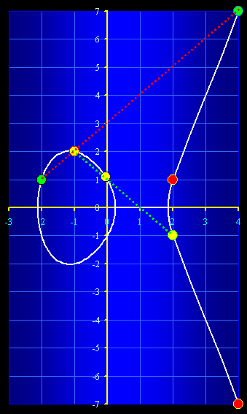

Point Addition on E(F_{p})
There is an addition operation, called the chord-and-tangent rule, for adding two points (x₁, y₁) and (x₂, y₂) on an elliptic curve E(F_{p}) to give a third elliptic curve point (x₃, y₃). This addition operation, the set of points forms a mathematical group with (∝_{x}, ∝_{y}) serving as its identity. This group shall be used in the construction of elliptic curve cryptosystems.

The addition operation is best explained geometrically. Let (x₁, y₁) and (x₂, y₂) be two distinct points on an elliptic curve E: y² = x³ + ax + b as shown in the figure below. Then the sum
(x₃, y₃) = (x₁, y₁) ⊕ (x₂, y₂)

is defined as follows.

First draw the line through (x₁, y₁) and (x₂, y₂) until it intersects the elliptic curve on another point. Then the sum (x₃, y₃) is the reflection of this point with respect to the x-axis.
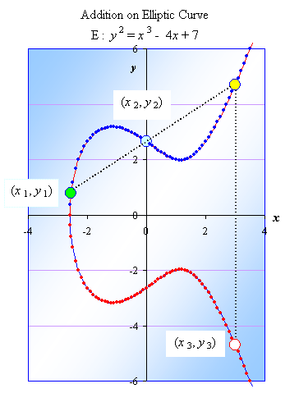

Double Point on E(F_{p})
In the case of (x₁, y₁) = (x₂, y₂), adding the two points on an elliptic curve E(F_{p}) is popularly known as doubling operation. This will give a third elliptic curve point (x₄, y₄). This doubling operation will be set according to tangent rule on the elliptic curve.

Geometrically, let (x₁, y₁) be a point on an elliptic curve E: y² = x³ + ax + b as shown in the figure below. Then,

(x₄, y₄) = 2 ⊗ (x₁, y₁)

is defined as follows.

First draw the tangent line through (x₁, y₁) and trace along the line until it intersects the elliptic curve on another point. Then the 2 ⊗ (x₁, y₁) is the reflection of this point with respect to the x-axis or also called the conjugate.

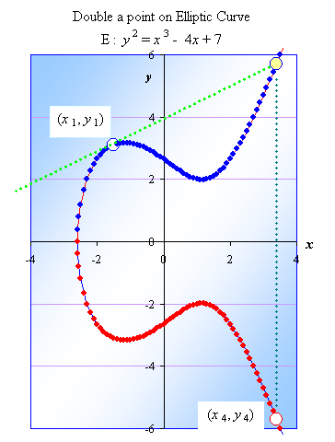

g i
The following algebraic formulae for the sum of two points and the double of a point can now be derived from the geometric description.

- Let the identity I = (+∞_{x}, +∞_{y}). It is a point at infinity. Nevertheless, think of it as a point of origin which carry zero value.
I ⊕ (x, y) = (x, y) ⊕ I = (x, y).

- (x, –y) is called the negative of (x, y) and observe that is indeed a point on the curve since the curve is symmetric with respect to the x–axis.
(x, –y) ⊕ (x, y) = I.

- Let (x₁, y₁) and (x₂, y₂) are two points on an elliptic curve E(F_{p}), and
(x₁, y₁) ≠ (x₂, ± y₂)
then let
(x₃, y₃) = (x₁, y₁) ⊕ (x₂, y₂) such that

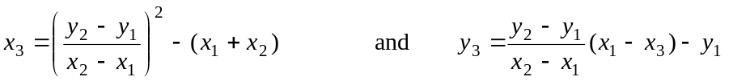

Let the slope
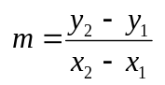of the secant line connecting (x₁, y₁) and (x₂, y₂)
then
x₃ = m² – (x₁ + x₂) and y₃ = m(x₁ – x₃ ) – y₁.

- Let (x₁, y₁) be a point on an elliptic curve E(F_{p}), and (x₁, y₁) ≠ (x₂, –y₂)
then let
(x₄, y₄) = 2 ⊕ (x₁, y₁) such that

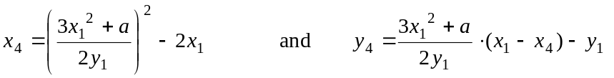

Let slope of the tangent line
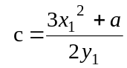 ,
then
x₄ = c² – 2x₁ and y₄ = c (x₁ – x₄ ) – y₁.

It should be noted that the addition of two elliptic curve points above requires a few arithmetic operations (addition, subtraction, multiplication and inversion) in the underlying field F_{p}.
example:
Let p = 23 and consider the elliptic curve E: y² = x³ + x + 4 defined over F₂₃. Let (x₁, y₁) = (4, 7) and (x₂, y₂) = (13, 11) be points on E(F₂₃). To compute (x₃, y₃) = (x₁, y₁) ⊕ (x₂, y₂)
First, compute
m = 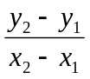 (mod p)
= 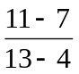 (mod 23)
= 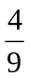
= 4 ⋅ 9^{–1} (mod 23)
= 4 ⋅ 18 (mod 23)
= 72 ≡ 3 (mod 23).
Then,
x₃ = m² – (x₁ + x₂) and y₃ = m(x₁ – x₃ ) – y₁.
= 3² – (4 + 13) = 3⋅(4 – 15) – 7.
= 9 – 17 = 3⋅(– 11) – 7.
= – 8 = – 40
≡ 15 (mod 23) ≡ 6 (mod 23)

Thus,
(x₃, y₃) = (15, 6).

To compute (x₄, y₄) = 2 ⊕ (x₁, y₁) = 2 ⊕ (4, 7) so that

x₄ = (3x₁² +a )² / (2y₁)² – 2x₁ and y₃ = (x₁ – x₄ ) (3x₁² +a )² / (2y₁)² – y₁.

First, let us compute the slope of the tangent line

c = 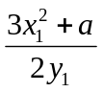 mod p.
= 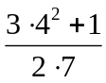
= (3⋅16 + 4)/14
= (48 +1)/14
≡ (49)/14
=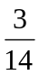
= 3 ⋅14^{–1} (mod 23)
= 3 ⋅5
= 15 (mod 23).

and c² = 15² = 225 ≡18 (mod 23). Then,
x₃ = c² – 2x₁ and y₃ = c ⋅ (x₁ – x₄ ) – y₁.
= 18 – 2⋅4 = 15 ⋅ (4 – 10) – 7
= 18 – 8 = 15 ⋅ (–6) – 7
= 10 (mod 23). = – 97 ≡18 (mod 23).
So,
(x₄, y₄) = 2 ⊕ (x₁, y₁) = 2 ⊕ (4, 7) = (10, 18).

Let us take another example: Let p = 257 be an odd prime. An elliptic curve E over the field F_{p} is defined by an equation of
the form
y² = x³ + ax + b

where a = 17 ∈ F_{p}, b ∈ F_{p}, and 4a³ + 27b² ≠ 0 (mod p).

Step 1. Choose the base point

Take a base point at x = 2, y² = 2³ +17⋅2 + b = 8 + 34 + b = 42 + b = 49. Then we can take b = 7. And let the base point (x₁, y₁) = (2, 7). Now we can check that
4a³ + 27b² = 4⋅8 + 27⋅49 = 32 + 1323 = 1355 ≡ 70 (mod p).

Now the elliptic curve E: y² = x³ + 17x + 7 over finite field F₂₅₇.
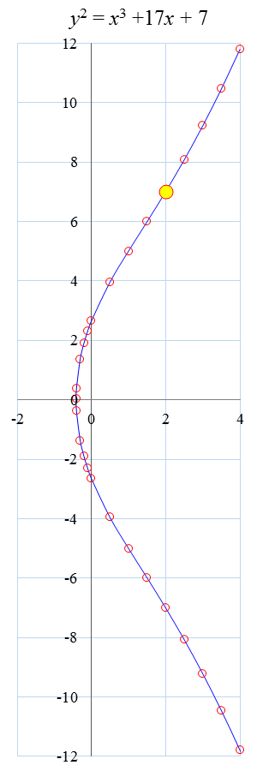
Step 2: Choose a random private key.
Let the private key λ = 3.
Step 3: Compute the projection point (x_{λ}, y_{λ}) = λ(x₁, y₁).
Thus, (x₁, y₁) and (x_{λ}, y_{λ}) is the public key.
(x₂, y₂) = 2 (x₁, y₁)
(x₃, y₃) = (x₁, y₁) + (x₂, y₂).
Now the elliptic curve E: y² = x³ + 17x + 7 over finite field F₂₅₇.
From the base point P₁(x₁, y₁) = (2, 7)
P₂ (x₂, y₂) = 2 P₁ (x₁, y₁) by calling the double point function.

(x₂, y₂) = 2 ⊕ (x₁, y₁) such that

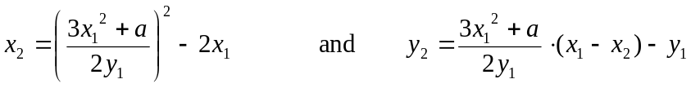

Let slope of the tangent line
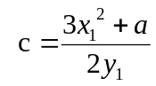 =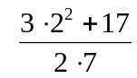= 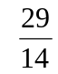, we need to compute 14⁻¹ mod 257
14⁻¹ ≡ 202 (mod 257)

Then c =≡ 29⋅202 = 5858 ≡ 204 (mod 257)
then
x₂ = c² – 2x₁ = 204² − 2⋅2 = 41612 ≡ 235 (mod 257)

and y₂ = c (x₁ – x₂) – y₁ = 204(2 – 235) – 7 = −47539 ≡ 6 (mod 257)

Given (x₁, y₁) = (2, 7) and (x₂, y₂) =(235, 6) are two points on an elliptic curve E(F_{p}), and
(x₁, y₁) ≠ (x₂, ± y₂)
then let
(x₃, y₃) = (x₁, y₁) ⊕ (x₂, y₂) such that

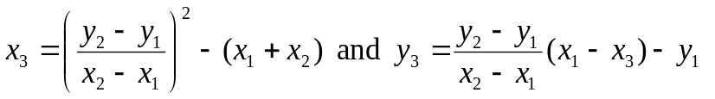

Let the slope
= 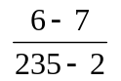 = 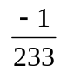
of the line connecting (x₁, y₁) and (x₂, y₂). We need to compute the 233⁻¹ mod 257.
The inverse 233⁻¹ ≡ 182 mod 257. Let us continue
= ≡ −1⋅182 = −182 + 257 = 75 (mod 257).

Thus,
x₃ = m² – (x₁ + x₂) = 75² – (2+235) = 5388 ≡ 248 (mod 257) and y₃ = m(x₁ – x₃ ) – y₁ = 75(2 – 248) – 7= −18457 ≡ 47 (mod257)
Again, take the private key d = 3, and then the public key P₁(2, 7) and P₃(248, 47).

Small Exercise: Let p = 23 and consider the elliptic curve E: y² = x³ + x + 4 defined over F₂₃. Take λ = 3.
Choose a base point P and compute 3P.

Point Projection over E(F_{p})
The point addition and doubling operations on an elliptic curve E(F_{p}) give a way for point projection. This operation, the set of points forms an algebraic structure as a group with (+∞_{x}, +∞_{y}) serving as its identity. This group shall be used in the construction of elliptic curve cryptosystems.

Let P = (x, y) be a point on the Elliptic Curve

E: y² = x³ + ax + b
then define
1 ⊗ P = P,
2 ⊗ P = P ⊕ P,
3 ⊗ P = P ⊕ P ⊕ P,
:
λ ⊗ P = P ⊕ P ⊕ P ⊕ … ⊕ P.
λ times

This is analogous to the way power operation is defined in regular arithmetics;
x^1 = x,
x^2 = x ⋅ x,
x^3 = x ⋅ x ⋅ x,
:
x^κ = x ⋅ x ⋅ x ⋅ … ⋅ x,
κ times

Let us take an example[50]. Let an elliptic curve be

E: y² = x³ – 43x + 166

Take a point on the curve P = (3, 8). A multiple of P is illustrated in the graph below.

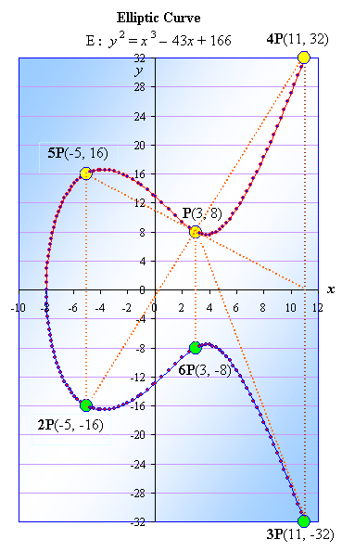

In this case, following the rule point addition;

1 ⊗ P = P = (3, 8),
2 ⊗ P = P ⊕ P = (–5, –16),
3 ⊗ P = 2P ⊕ P = (11, –32),
4 ⊗ P = 3P ⊕ P = (11, 32),
5 ⊗ P = 4P ⊕ P = (–5, 16),
6 ⊗ P = 5P ⊕ P = (3, –8),
7 ⊗ P = 6P ⊕ P
= (3, –8) ⊕ (3, 8)
= (+∞, +∞) = I.

It should be pointed out that 7P is already equal to the identity as a point at infinity. The cycle will repeat it self from here on.

8 ⊗ P = 7P ⊕ P
= I ⊕ (3, 8) = (3, 8),
9 ⊗ P = 8P ⊕ P = (–5, –16),
10 ⊗ P = 9P ⊕ P = (11, –32),
11 ⊗ P = 10P ⊕ P = (11, 32),
12 ⊗ P = 11P ⊕ P = (–5, 16),
13 ⊗ P = 12P ⊕ P = (3, –8),
14 ⊗ P = 13P ⊕ P
= (+∞, +∞) = I.
And so on.

The period of the cycle here is known as the order of the point P.
#{ (3, 8) } = 7.

Suppose the base point (3, 8). Let us take the private key d = 11.
The public projection key is d(3, 8) = 11(3, 8).
Let us write the private key 11 = 8+2+1 = 1011₂.

In general d = d_{n−1} ….d₁ d₀ = 1011₂.
Starting from P(3, 8), let us compute 2P(3, 8) = (–5, –16),
____________________________
Procedure Q = Multiply(d, P)
____________________________

P(3, 8), Q(+∞,+∞)
for i=0:i<n:i++

if d_{i} = 1,
then Q = P ⊕ Q;
P = 2P;
end return Q.
____________________________

Let us track the procedure Q = Multiply(11, P)
Initially, d₀ = 1, Q = P ⊕ Q = (3, 8) ⊕ Q(+∞,+∞) = (3, 8). P = 2P(3, 8) = (–5, –16).

First, d₁ = 1, Q = P ⊕ Q = (–5, –16) ⊕ (3, 8) = (11,−32). P = 2P(–5, –16) = (11, 32).

Second, d₂ = 0, P = 2P(11, 32). = (3, 8).

Third, d₃ = 1, Q = P ⊕ Q = (3, 8) ⊕ (11,−32) = (11, 32).

Example of Point Projection on an Elliptic Curve.
Let P = (–3, –9) be a fixed point on the global Elliptic Curve

E: y² = x³ – 29x + 21

Then there λ such that

(5, 1) = λ (–3, –9)
as shown by the graph below.
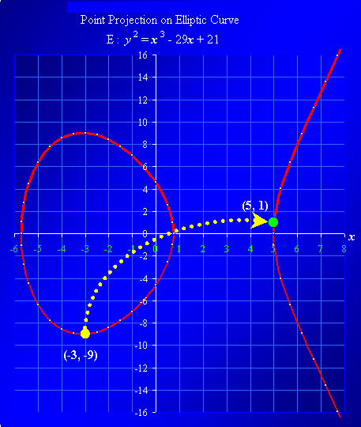

ECC Encryption Mode
This is the simplest mode of encryption via ECC. Let P = (x₀, y₀) be a fixed base point on the global Elliptic Curve

E: y² = x³ + ax + b mod p.

Alice choose her private key λ_{A} and compute her public key as
(x_{A}, y_{A}) = λ_{A} ⊗ (x₀, y₀).
Bob also choose her private key λ_{B} and compute her public key as
(x_{B}, y_{B}) = λ_{B} ⊗ (x₀, y₀).
respectively.
- In following the Diffie Hellman style,
Alice may now encrypt to Bob by generating session key by taking a projection point using her private key and Bob’s public key,
(x_{C}, y_{C}) = λ_{A} ⊗ (x_{B}, y_{B}).
Once, Bob get the message based their agreed symmetric encryption, he will regenerate the session key using his private key and Alice’s public key.
λ_{B} ⊗ (x_{A}, y_{A}) = λ_{B} ⊗{λ_{A} ⊗ (x₀, y₀)}
= λ_{A} ⊗{λ_{B} ⊗ (x₀, y₀)}
= λ_{A} ⊗ (x_{B}, y_{B}).
= (x_{C}, y_{C}).

In order to determine λ from either public keys (x_{A}, y_{A}) or (x_{B}, y_{B}) and corresponding session is classified as an ECDLP or discreet logarithm problem on E(F_{p}). Thus this mode of encryption is considered secure.

- Let us see the encryption mode following the RSA style,
Suppose Alice want to encrypt a message to Bob.
She will generate an Encrypt key λ_{E}. She will project the base point and Bob public key using the Encrypt key λ_{E}.
(x_{C}, y_{C}) = λ_{E} (x₀, y₀) and (x_{D}, y_{D}) = λ_{E} (x_{B}, y_{B})
Alice will encrypt the message using (x_{D}, y_{D}) as a session key and send the (x_{C}, y_{C}) as the Encrypt basepoint.
(x₀, y₀)
(x_{B}, y_{B})
λ_{B}
(x_{C}, y_{C})
λ_{E}
λ_{E}
(x_{D}, y_{D})
λ_{B}

General Encryption Mode
Common techniques of encryption rely upon the PKI as the bigger key and symmetric encryption as lighter smaller key. The symmetric (sometimes called session) key will be pseudo-randomly generated and then encrypted using the PKI. It will be then stored as the header of the encrypted document. The content of the plaintext document will be encrypted with this session key as shown in Figure below.
DES

AES

Session
Key

Document

RSA

ECC

Encrypted
Key

Encrypted Document

General framework of current encryption mode.

The framework relies upon the strength of 3 algorithms;

- The Security strength of the PKI such as RSA, ECC or NTRU.
- The Security strength of the symmetric encryption being used such as DES or AES.
- The randomness or security of the session key generated.
There is direct domino effect from one to another building block of the framework. The security strength of overall system is mainly based upon the weakest point out of the 3 algorithms.

Reading Assignment: ECDSA document.
Assignment 1: ECC K-Curve + codes on the finite field 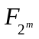
Assignment 2: NTRU + codes

